Interarriavl data:

Interarrival_Gamma:

The chi_sq test value is 21.038154 and the p-value is 0.000311

Interarrival_ Exponential:

The chi_sq test value is 20.761390 and the p-value is 0.000899

Interarrival_Erlang:

The parameters estimations are: k=1, loc(always)= 0, lamda= 3.843925

The chi_sq test value is 19.422471 and the p-value is 0.000649

Service time data:

ServiceTime_Gamma:

The chi_sq test value is 1.050774 and the p-value is 0.305329

ServiceTime_Exponential:

The chi_sq test value is 130.074024 and the p-value is 2.2954438432e-26

ServiceTime_erlang:

The parameters estimations are: k=3, loc(always)= 0, lamda= 1.214991

The chi_sq test value is 68.041901 and the p-value is 1.60057904133e-16

Comment:

Interarrival data is most likely are Gamma distributed, since the p value of Gamma distribution is least in the three distributions.

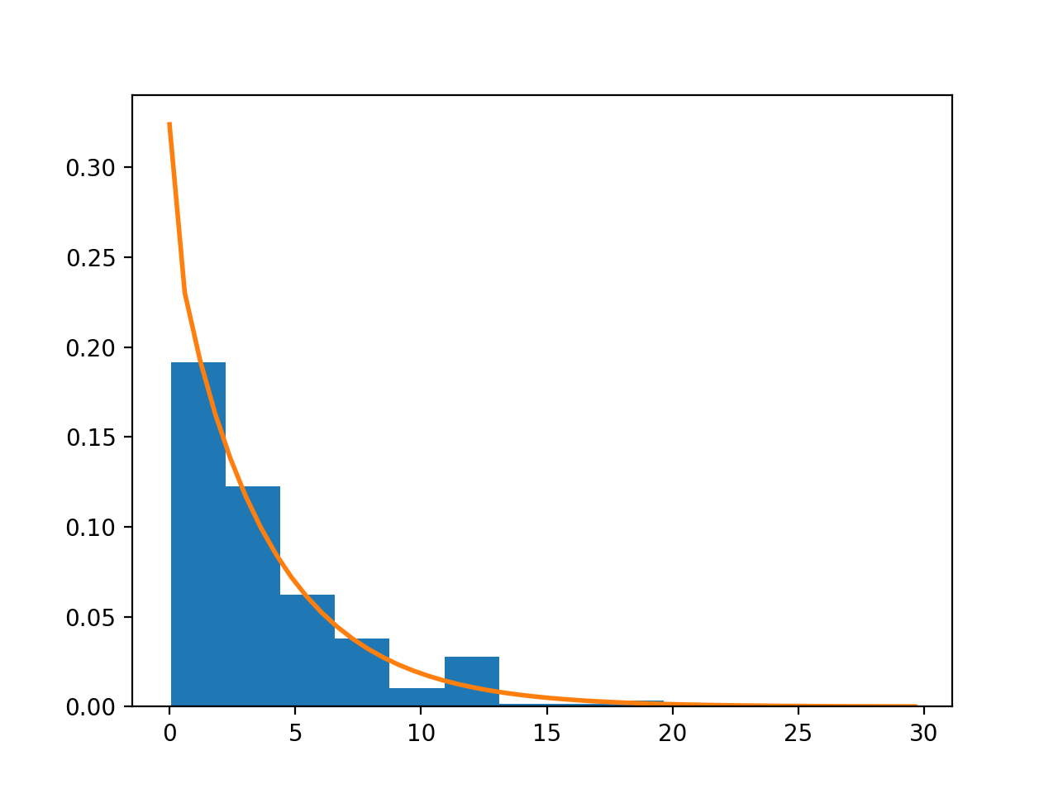

Service time data is most likely are Exponential distributed, since the p value of Exponential distribution is least in the three distributions.

